Client Meeting Agenda

# Topic: ME 476C Team Client Meeting

## Friday March 15th, 2024

## ~7:30am-8:30am

**Meeting called by:** Dr. Tom Acker

**Attendees:** Janelle,Courtney, Aaron, Steven, Maciej and Dr. Tom Acker

|  |  |  |
| --- | --- | --- |
| 7:30am-7:40am | Presentation of Roles and Schedule   * Report 1 Topics * Website Check | Room |
| 7:40am-8:15am | Website Discussion (Courtney and Steven)   * Should we include link to SRP?   Report 1 Topics Discussion   * Customer Requirements * Engineering Requirements * Concept Selection |  |
| 8:15am-8:20am | * Additional Questions |  |
| 8:20am-8:30am | Next week   * Analysis Memos coming up * Prototype testing plan |  |

**Meeting Notes:**

h

NPV

1. Compare 2 alternatives, do nothing but pay the electric bill, can do it on an annual basis, PHX is probably in the $1000’s.
2. The material product is the initial investment, maitence how many times a year does the CM need to be replaced
3. If it comes out positive it is a good product, where if it is less than it is a poor product
4. Put it in a spreadsheet, and create a NPV table
5. Compare with each design will drive what our decision for the final design will be
6. Has to save a LOT of money
7. We need to pick a lifetime for the life expectancy of the device. Not based on electricity bill because that is forever
8. I is the discount rate
9. What rate of return, what is the intrest rate on that money, the morgae rate becomes the cost of money
10. What people expect as a rate of return on the device, Find papers on discount rates
11. 8% is about what SRP’s 4% is more normal
12. The NPV and internal rate of return are what we want. We need a strong internal rate of return value,
13. Discount rate is huge and important to understand in this project. We NEED to understand that

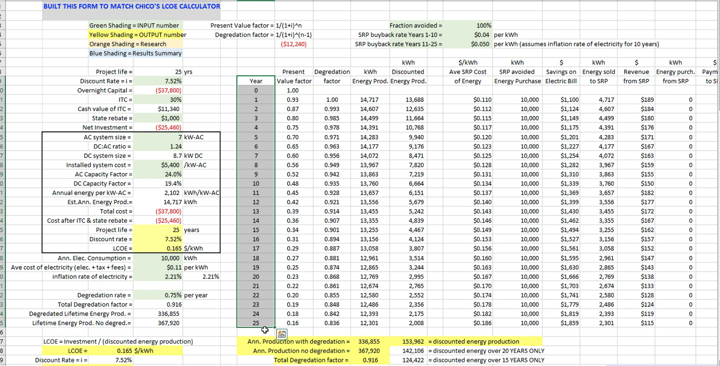

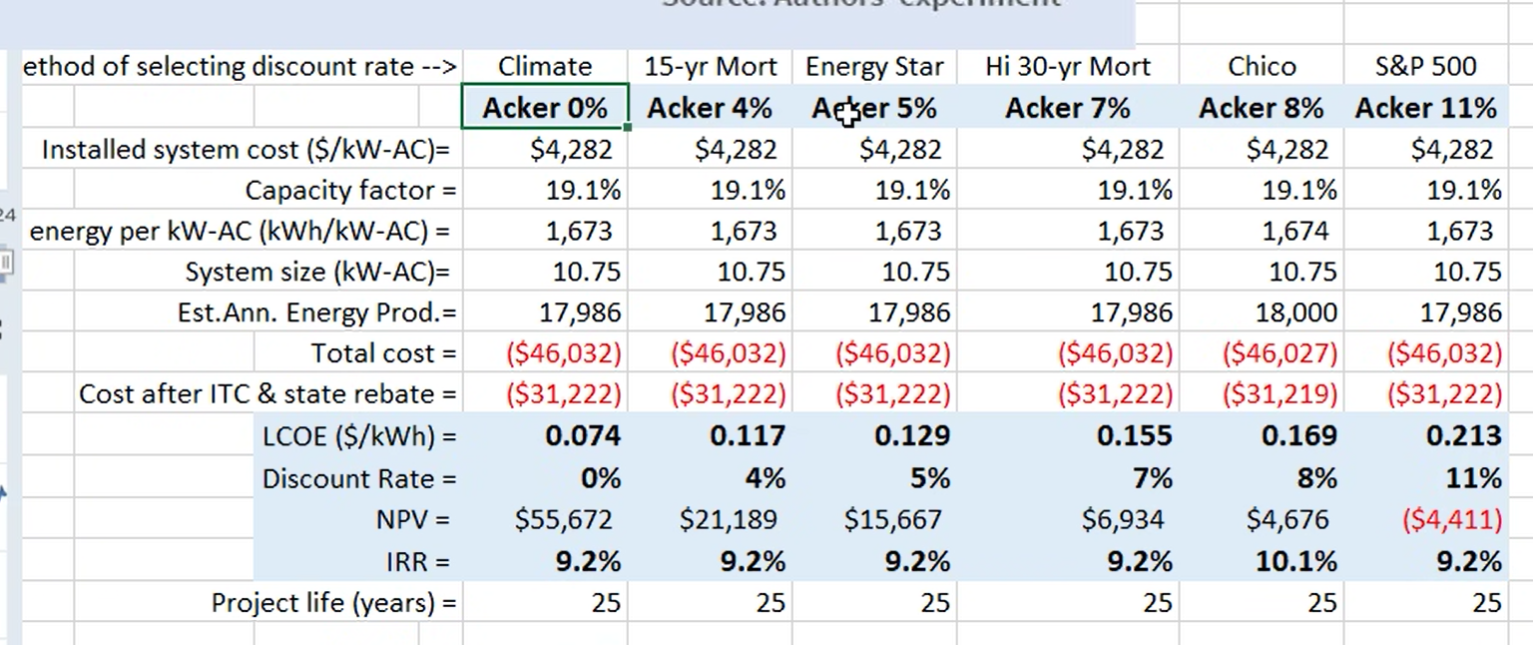

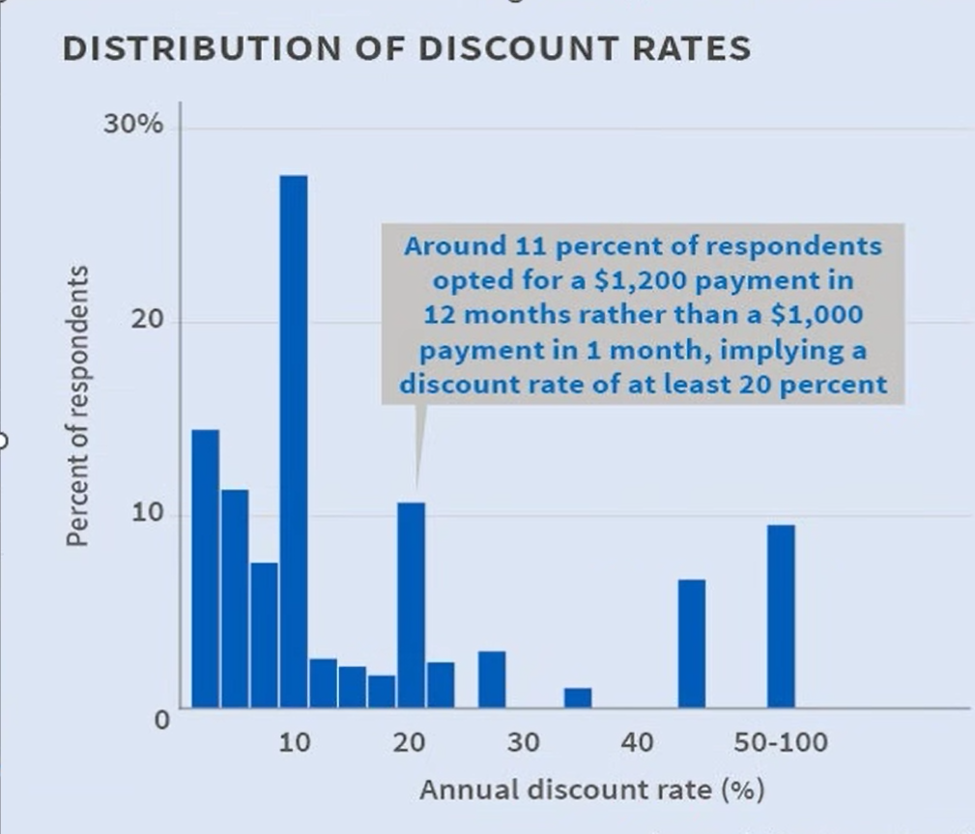

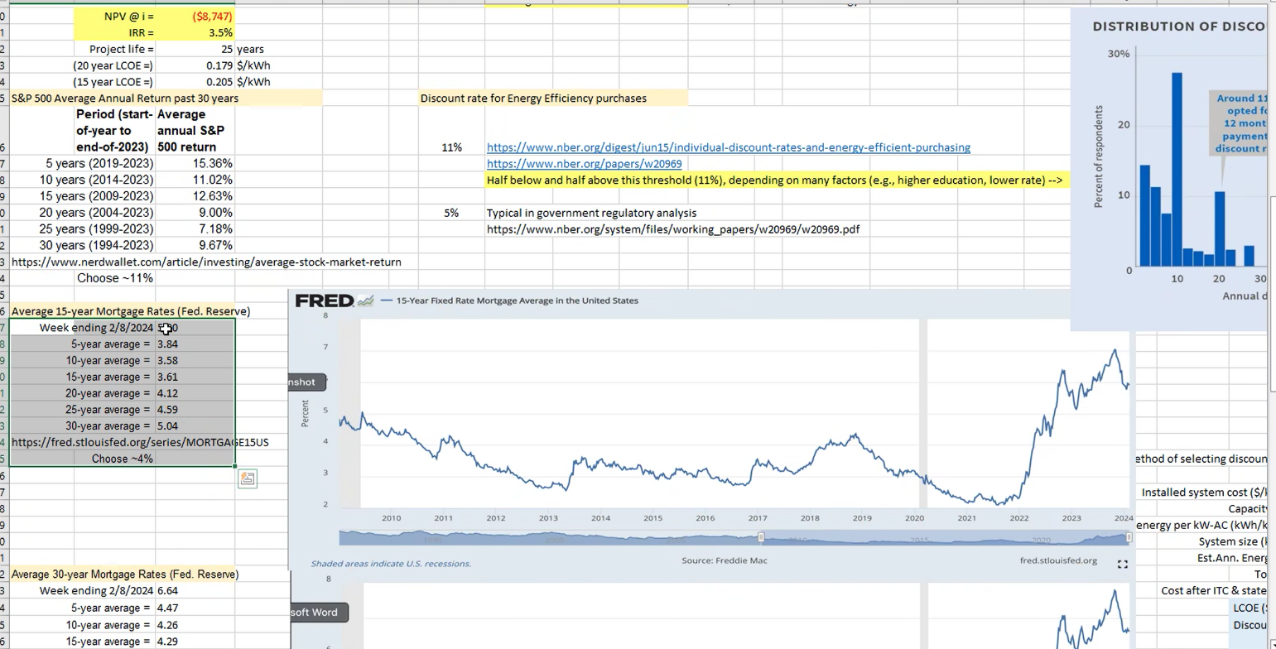

Website

Add a page and link to SRP’s public landing page

Decision Matrix

Internal rate of return are key factors in anything

Ideas that have a negative NVP they are not going to be considered. PERIOD

Comfort level- will it keep the house cool and help with the load

Ease of Maintenace and operating cost

Load and power saving are the same thing

Split the new build and existing- and do what calculations we need for the product, which market are we planning on doing. He wants us to pick based on the ideas we have. He wants us to go with based on what we are enthusiastic about. Based on the NVP for each

Reject number- If it rates below a number, we just don’t do it

Final Design

We need to do the thermal analysis if we are taking out the refrigerant, if not we just need to find the heat being dissipated from the line

We are taking the

2 choices take the cold air the other take the refrigerant

Think of a freezer

Micro PCM panel

If we put the PCM directly into a device like courtneys, if we could use the PCM

Steven’s overall is a simplified model of everything

How are we storing it? How do we cool the air down?

Compressor only compresses gases not liquid

We can buy a cheap AC device and take it apart for parts

Vent refrigerant and then how to load it back into the system

There is an HVAC person on campus who can do it for us, we need an HVAC professional to do that for us

If we cut into the lines we need an HVAC person

If we make our own we need someone to help us

Material Analysis

This is a great start

The 12 kw AC find out what the typical AC load is i a house

It is basically saying how much ice can it freeze in an hour

Everyone needs to calculate the efficiency for each part of the design

What is the efficiency of this unit

We can do a CFD model on this, but we can do first law and heat transfer calculations

Compare basic battery storage with our device

2 analysis

Financial NVP analysis on each device

We each have a device and we need to run a heat transfer analysis on each portion. When we are releasing the heat and when we are recharging the device. Each needs a thermal analysis, using the first law of thermodynamics, and heat exchanger

Refrigerant cycle analysis